**Introduction Cloud Computing**

**-----------------------------------------**

**History of Computing:**

1. Bare Metal: A single host machine (Hardware), you can compare with your computer or Laptop at home. Without sharing, will not get the benefits of cost.

The physical host machine will have some core capabilities (Core feature of any physical machine) like, **Compute**: CPU, RAM, etc., **Storage**: Hard Disk,

**Networking**: A network card base through which you can connect internet.

Physical machine: --One setup Compute

--One Setup Storage

--One Setup Networking

Suppose, we have 4 virtual machines in this one physical host machine.

So will you divide this one setup compute, storage, & Networking among all these virtual machines

1. Server Virtualization: A single physical host machine could have multiple virtual machines, (Virtual means not real but people looking at it and getting a feeling that it is real).

**Hypervisor**

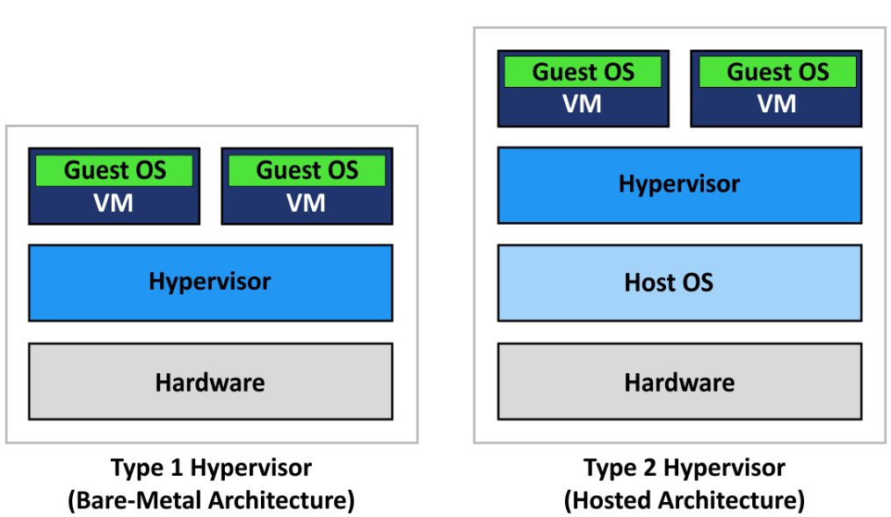

A hypervisor, known as a virtual machine (VM), is software that creates and runs virtual machines (VMs).

A hypervisor allows one host computer to support multiple guest VMs by virtually sharing its resources, such as memory and processing.

There is a software component called "Hypervisor". This is the way who help us share these One setup compute, storage, and networking resources with all these VMs.

There **are 2 types of Hypervisors**,

**1. Type1 Hypervisor**: Use Cloud Provider.

If you have a Bare metal machine, nothing will be there then you will have Hypervisor s/w installed and on top of multiple VMs with different OS.

You will have a Single HOST machine.

You need to install Hypervisor S/W.

That Hypervisor S/W is called Type1 Hypervisor on top of different VMs running in different OS.

Type 1 hypervisor acts like a lightweight operating system and runs directly on the host’s hardware,

**2. Type2 Hypervisor**: Use Testing or Learning Purpose or Hosted

There are two main hypervisor types, referred to as “Type 1” (or “bare metal”) and

Type 2 hypervisor runs as a software layer on an operating system, like other computer programs.

Different Types of Hypervisor,

1. VMware ESXi/vSphere

2. Microsoft Hyper-V

3. Citrix XenServer

4. Oracle VirtualBox

5. Red Hat Enterprise Virtualization ( Red Hat also has a virtualisation offering based on the Kernel-Based Virtual Machine, an open source hypervisor.)

<https://www.vmware.com/topics/glossary/content/hypervisor.html#:~:text=There%20are%20two%20main%20hypervisor,system%2C%20like%20other%20computer%20programs>

1. Container (e.g. Docker): A Docker container is an open source software development platform. Its main benefit is to package applications in containers, allowing them to be portable to any system running a Linux or Windows operating system (OS).
2. Container Orchestration (e.g. Kubernetes, k8s): Kubernetes is an open-source container orchestration platform for managing, automating, and scaling containerized applications.

**Feature of Cloud:**

**High Availability,**

**Scalability,**

**Elasticity,**

**Fault Tolerance,**

**Disaster Recovery,**

**Low Latency,**

1. **Cloud Service Providers:**

A cloud provider is a company that delivers services and solutions that are based on cloud computing to businesses and/or individuals.

Ex. AWS, Azure, GCP, etc.

Reference: <https://aws.amazon.com/about-aws/global-infrastructure/>

1. **Cloud Computing**

It is the delivery of computing services (Servers, Storage, Databases, Networking, S/W) over the internet.

On-Demand (Anytime you can create, once do not need to remove it ) and Automated provisioning of computer resources. Ex. Computing, Networking & Storage.

“Pay-Per-Use” or “Pay-as-you-go”, It will charge for the time when using the software.

Cloud computing is when you use a computer/server which is provided to you by someone else.

This server has to be accessed over the internet by using a web-based tool for personal or business use.

**Cloud Computing = Virtualization + Internet/Intranet**

In the simplest term, Cloud Computing is storing and accessing data and programs over the internet.

Benefits of Cloud Computing:

* + Better Scalability (able to be changed in size or scale)
  + Improved Security

1. **Cloud Modules (Cloud Deployment Models)**

There are three types of clouds − Public, Private, and Hybrid cloud.

**Public Cloud (AWS, MS Azure, GCP, IBM Bluemix etc.)**

In the public cloud, third-party service providers make resources and services available to their customers via the Internet.

Customer’s data and related security is with the service providers’ owned infrastructure.

**Private Cloud (HPE, VMware, Red Hat Open Stack, Dell EMC, etc.)**

A private cloud also provides almost similar features to a public cloud, but the data and services are managed by the organization or by a third party only for the customer’s organization.

In this type of cloud, major control is over the infrastructure so security-related issues are minimized.

**Hybrid Cloud**

A hybrid cloud is a combination of both private and public clouds.

The decision to run on a private or public cloud usually depends on various parameters like the sensitivity of data and applications, industry certifications required standards, regulations, etc.

1. **Cloud Services (Cloud Service Model)**

Cloud services are infrastructure, platforms, or software that are hosted by third-party providers and made available to users through the Internet**.**

There are **three types** of service models in the cloud − **IaaS, PaaS, and SaaS**.

**IaaS (**Infrastructure as a Service), Configure & manage the H/W on own.

Ex: AWS, MS Azure, etc.

Infrastructure as a Service is renting the infrastructure to run your application and OS.

It gives reasonable control and flexibility over your infrastructure for reduced complexity and management costs.

While there is no direct control over the underlying hardware, network, or virtualization you still can install and manage your own OS and applications running on the infrastructure.

**PaaS (**Platform as a Service)

Platform managed by Cloud Provider.

Ex: AWS Elastic Beanstalk

Platform as a Service allows you to host your custom application where the provider handles everything for you except your application and your data, they provide the infrastructure, OS, and services required to run your application.

You don’t have to worry about hardware, network, or managing the OS, and underlying software to run your application.

You can focus on the development of your application and easily scale as you require additional resources.

**SaaS (**Software as a Service)

end-user (Pay-as-you-go)

Ex: Google Drive, MS Office 365, Google Docs, payroll application, etc.

The entire application is provided to you in a hosted format, you don’t need to worry about running anything below the application such as the infrastructure, OS, services, etc.

This is the easiest to manage in terms of management, however the least flexible.

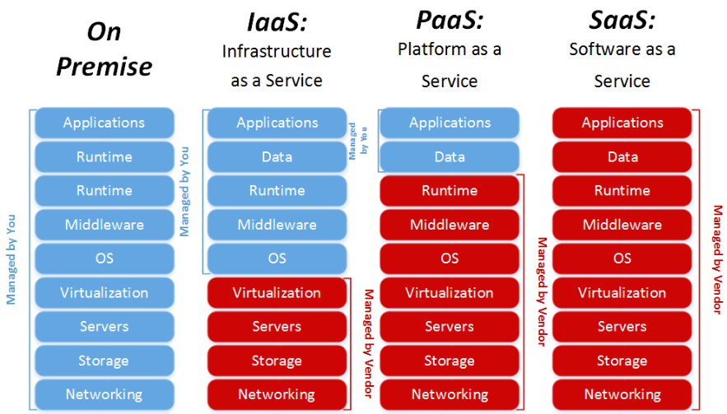

1. **Cost Effective Solution Cloud computing**

Effect on,

CAPEX (Capital Expenditure Expenses), is where you pay for something upfront (of a payment in advance).

And OPEX (Operational Expenditure Expenses), the “Pay-as-you-go” model, you pay for services as you use them.

Note: When you move from the on-premises cloud to the public cloud, is the switch from Capital Expenditure (Buying Hardware) to Operational Expenditure (paying for service as you use it).

**AWS**

It is the lead cloud computing platform, Amazon Web Services (AWS).

AWS provides servers, storage, networking, remote computing, and security.

Amazon web service is **an online platform that provides scalable and cost-effective cloud computing solutions**.

AWS is a broadly adopted cloud platform that offers several on-demand operations like compute power, database storage, content delivery, etc., to help corporations scale and grow.

**Region**

An AWS Region is a geographical location with a collection of availability zones mapped to physical data centers in that region.

AWS has the concept of a Region, which is a physical location around the world where we cluster data centers.

We call each group of logical data centers an Availability Zone.

Each AWS Region consists of multiple, isolated, and physically separate AZs within a geographic area.

**The AWS Cloud spans 84 Availability Zones within 26 geographic regions around the world.**

**Availability Zone (AZ)**

An availability zone is **a logical data center in a region available for use by any AWS customer**.

**Edge location**

An edge location is **the nearest point to the consumer (user) who is consuming the AWS service**.

**A site that CloudFront uses to cache copies of your content for faster delivery to users at any location**.